Otto-von-Guericke-University Magdeburg

Faculty of Electrical Engineering and Information Technology

Chair for Electromagnetic Compatibility

Degree Thesis



Characterization and Automated Alignment Detection of an Additively Manufactured Z-frame Marker to Process Signals for Robotic Control in Interventional MRI

Submitted: August 01, 2018

By: Parisa Parsanejad

Born on June 23, 1991

In Esfahan, Iran

**Abstract**

**Task of the Thesis in the Origin:**

**Declaration by the candidate**

I hereby declare that this thesis is my own work and effort and that it has not been submitted anywhere for any award. Where other sources of information have been used, they have been marked.

The work has not been presented in the same or a similar form to any other testing authority and has not been made public.

Magdeburg, August 01, 2018

**Contents**

**List of Acronyms**

**List of Figures**

**List of Tables**

1. **Introduction**

**Registration**

**1.1 Motivation**

**1.2 Objectives**

1. **Literature Survey**
   1. **Magnetic Resonance Imaging (MRI)**

MRI is a non-invasive imaging technology generating three dimensional anatomical and functional images of the body without the use of ionizing radiation. It is particularly useful for neurological, oncological, cardiovascular, muscular and skeletal imaging. MRI employs a powerful magnetic field that forces the hydrogen atoms in the tissue being imaged to align with its axis. The additional radiofrequency fields are then used to stimulate the protons and alter the alignment of the magnetization. When the radiofrequency fields are turned off, the protons realign with the magnetic field and release the detectable energy by MRI scanner. It defines different MRI parameters such as repetition time and echo time which are the time between two consecutive excitation pulses and the time between the excitation pulse and the recording of the magnetization value, respectively.

**2.1 Pulse sequences**

A pulse sequence is the measurement technique and contains multiple parameters such as RF pulses, gradient pulses, and timing. Depending on the anatomical region under observation, the optimal pulse sequence has to be chosen in order to acquire the data in the desired manner. There are three general criteria that should be considered when modifying the measurement parameters of a pulse sequence through the user interface software: acceptable scan time, adequate spatial resolution, and the sufficient contrast between tissue relative to the background noise (contrast-to-noise ratio). Many pulse sequence parameters are available commonly which can be categorized by their effect on the MRI image as intrinsic and extrinsic parameters. Intrinsic parameters influence only the signal-producing portion of the image such as patient anatomy. Extrinsic parameters affect factors external to the tissue and the structure of the data collection such as voxel size.

Despite the non-ionizing radiation characteristics, MRI imaging experiences different imaging artefacts which generate difficulties for the detection and registration task.

**2.2 Artifacts in MR imaging**

In the MR images, artifacts refer to pixels that do not truly represent the anatomy being studied. Artefacts can be categorized into three groups, according to the cause of the signal misregistration. The first group refers to artefacts that are produced by the patient tissue movement during data acquisition. The second group is a consequence of the measurement technique and parameters. The last group are independent of the patient or measurement technique and are generated from an external source to the patient or scanner.

**2.2.1 Motion artifacts**

The motion artifacts are caused by tissue that is excited at one location, producing signals that are mapped to a different location during detection. The specific appearance of the artifact depends on the nature of the motion and the measurement technique. If the motion is periodic, the produced artefact is discrete, often referred to as “ghosts”. Moreover, the sensitivity of a measurement to tissue motion depends on the amount of frequency and phase variation that occurs between successive echoes due to tissue movement. In abdominal or lumbar spine imaging, respiratory motion is the most common causes of the motion artefacts.

**2.2.2 Sequence/Protocol-related artifacts**

In this class of artifacts, the specific measurement parameters cause the artifact in the image. The source of these artefacts is relatively constant during the measurement.

**2.2.2.1 Aliasing**

The acquisition matrix and FOV in the specific measurement technique are two important factors determining a different phase and frequency to each location in the image. Aliasing artifact occurs both in the readout and phase encoding directions. If the selected FOV in the readout direction is smaller than the anatomical slice, the tissue’s frequencies pass the Nyquist limit, and are mapped to a lower frequency. This situation happens in the readout direction and is called high-frequency aliasing. It can be avoided by enhancing the number of readout data while maintaining the same sampling time. Furthermore, when tissue outside the FOV in the phase encoding direction is excited, the protons experience phase changes and are transformed to a lower phase situation via the Fourier transformation. This is known as phase encoding aliasing that can only be eliminated by increasing the FOV in the phase encoding direction.

**2.2.2.2 Chemical shift artifacts**

Chemical shift artifacts emanate from the inherent 3.5 ppm frequency difference between fat and water protons under the effect of an external magnetic field. One consequence of this frequency difference is a misregistration of fat and water protons from a voxel that are mapped to different pixels. In MRI, the exact magnetic field is dependent on the location inside the magnet according to the equation (1?); consequently, the detected signal from a proton (better voxel) is localized based on its frequency:

Bi=B0+GT ri

Where B0 is the main magnetic field, Bi is the magnetic field at location ri and GT is the total gradient amplitude.

Due to the fact that fat and water protons have a different molecular structure, they resonate at a lower frequency than water protons when exposed to the same gradient field. Accordingly, they will be mapped to a lower frequency pixel in the readout direction by the same GRO within a voxel. This misregistration is not perceivable in tissues with a consistent fat-water content. However, at the borders between tissues with an indicatively different fat-water content chemical shift artifact is visible. The number of pixels resembling chemical shift artifact (CSA) can be estimated according to the equation 2?:

CAS = $Δ_{ω}*N_{RO}∕Bw_{REC}$

Where $Δ_{ω}$ represents the frequency difference between fat and water protons in a voxel, $Bw_{REC}$ is the total receiver bandwidth, and $N_{RO}$ shows the number of readout data points spanning the FOVRO.

**2.2.2.3 Phase cancellation artifact**

Phase cancellation artifact is the second type of chemical shift-based artifact which arise from the frequency difference between fat and water protons. This artifact is visualized in out-of-phase gradient echo images. As shown in Figure 2.1, the fat protons cycle in phase relative to the water proton precession at a rate linearly proportional to the measurement time after the initial RF excitation pulse. Combine the net search : http://www.revisemri.com/questions/artefacts/phase_cancellation

**Figure 2.1** precession of fat and water protons. More explanation in book.



**2.1.0 Signal-to-Noise Ratio and Tradeoffs**

One of the most important characteristics of the MRI image data is the signal-to-noise ratio (SNR). The SNR in MRI images depends on the level of signal and the level of noise present in the data. There are different kinds of factors influence on the level of noise and signal in the MRI images. For instance, larger voxel size increases the SNR because the voxel contains more signal. Longer sampling time decreases the noise, and thus increases the SNR, the receive coil sensitivity and volume and the tissue. In addition, the receive coil volume and sensitivity contribute to the SNR. Furthermore, the tissue characteristics and its relaxation affect the SNR. These effects can be shown as follows:

SNR= V*T1/2 *R(B0, B1,…) * Iseq (T1,T2,TE,TR,…) (1.1)

Where V is the voxel volume, T is the total sampling time for each voxel, R is a factor characterizing the effects of the main magnetic field, the receive coil sensitivity and so force, and Iseq is a factor characterizing the signal intensity form the pulse sequence and the tissue.

**Registration**

Registration is an important operation of surgical guidance and the accuracy of the guidance is based on the registration method. In fact, registration determines a geometrical transformation that aligns different views of an object. A “view” can be an image, such as CT or MR, or it can be the physical object itself. In this work, registration referred as “image-to-physical” registration, where

There are different types of registration. In this section

**Opposite registration approach**

The main strength of this registration system is the ability to achieve concurrent registration in desired target alignment from a single slice image. Conventional registration methods usually …. In robotically assisted surgery, the end-effector of a robot can be registered to the scanner using a rigid body fiducial frame attached to the end-effector. However, this technique has a common problem that robot moves the fiducial frame out of the field of view, causing the image slice to become incomplete for registration. Figure 3? Illustrates an image of Masamun’s device with an incomplete number of fiducial rods. Traditional methods cannot handle this problem without acquiring extra images, which costs time. (numerical algorithm for spatial ...).

The algorithm has following advantageous:

It is resistant to noise in the input data. One of the input to the registration algorithm I the two-dimensional coordinates of the fiducials marks in the cross-sectional image. This information is produced by an image processing program at I not the subject of this investigation. It is conceivable that the locations of fiducial marks are not exactly identified in the medical images, due to suboptimal imaging and image processing techniques. These errors are considered to be “noise” in the input to the registration algorithm.

The algorithms must also run reasonably fast, in order to be useful in intraoperative applications. Computation time longer than one second? Would be prohibitive.

**3. Z-frame Characterization**

For tracking the instrument´s alignment in reference to its planned trajectory, the fiducial marker frame from Brown-Roberts-Wells, which is also called Z-frame based on its design of the fiducial marker structures, has been published many times as a concept for possible application in MRI-guided interventions. The marker is designed on the principle of a solid body that is crossed by a three-sided Z-shaped tunnel filled with liquid marker material. There are four vertical tunnels in every edge of the body and three 45° diagonal tunnels connecting all four vertical tunnels in three side faces of the body. Once the marker is measured in the MRI the tunnel structures are visible in a 2D-image plane as a very distinct pattern of seven circular areas, see Figure 2.



*Figure 1, left: Design principle of the Z-Marker with four vertical (z-direction) and three 45°‑diagonal tunnel structures filled with a marker fluid. The pointed image plane crosses all seven tunnels in perpendicular position to the Z-axis. Right: The Z-marker in a 2D-MR-image with view in +Z-direction and with all calculated center points of the circular areas [996].*

With the measurement of all distances between the circular areas, the marker alignment can be fully calculated in six degrees of freedom (6-DOF) in reference to the image plane alignment in the MR-image. However, the published marker concepts lacked in their fiducial characteristics or the feasibility for clinical application. Most reasons for it are founded in the design that has always been based on using at least two materials: one for the solid body and one for the fiducial liquid which is enclosed by it. For instance, the Z-frame-marker can be fabricated out of seven plastic capsules, which are filled with MRI-visible liquid (e.g. gadolinium: Gd, MR-SPOT® 121, Beekley Corp., Gd-capsule length: 32.0 mm, inner diameter: 6.2 mm) and that are placed inside the internal, z-shaped tunnel structures of the solid body, see Figure 3 left. Another method that has been applied for the Z-marker fabrication is the direct filling of a solid body with internal Z-shaped tunnel structures. This is made by one bore-hole which needs to be sealed up after filling, see Figure 3 right. That method owns the disadvantages for a complex and expensive fabrication process and a high risk for leakages.



Figure 2: Z-marker concept with Gd-based marker capsules inserted into a solid body frame (left and middle). Design concept with marker liquid directly injected into tunnel structures of the marker body but requiring additional sealing (right) [4, 995 - please update].

The mentioned method has the disadvantage that the plastic wall of the capsule, which is located between the body´s wall and the beginning of the MRI-visible liquid, can affect the precision of the marker detection negatively by shifting the center points of each tunnel due to geometric irregularities. Another issue that affects the marker precision in this design can be caused by the potential of certain artifacts. If the chemical shift artifact of a liquid marker material is too high, there is a relevant shift of the real center point to a virtual center point that results from the accumulation of the fat-based signal and the water-based signal. In worst case the geometric irregularities are superimposed with the chemical shift based irregularities leading to a significant inaccuracy of the precision of the marker [4 *- please update*].



Figure 3: Overview on potential geometric defects for fiducial markers using Gd-filled capsules (left and middle) and effect from the interpolated center point between the fat- and water-based circular artifact areas (right) [4 - please update].

In this project, a new concept for a fiducial marker is presented that is fully additively manufactured (commonly known as rapid-prototyping = RP) with only one polymer material. This one material is used for the fabrication of the solid Z-marker body and the internal marker liquid by using the method of stereolithography (SLA) technology [4 *- please update*]. The fabrication material for the marker-model is a liquid and photosensitive polymer, which is locally hardened by a laser beam. The model is built up layer by layer with the laser beam hardening the model volume. The principle of the SLA-method allows the enclosure of defined geometrical structures filled with unhardened liquid resin. These structures are created inside the solid model body without any openings to the outside. For this reason, only the structure surrounding the desired marker-geometry is hardened by the laser. The marker-geometry itself remains a liquid. Since it is made entirely from polymeric material, this marker is passive and totally MRI-safe.

**3.1 Z-frame physical structure**

In this project, the new physical feature structures of the Z-marker have been developed which improve the accuracy and speed of the registration procedure in interventional MRI. The two new features are center pointing triangles and the z-axis indication triangle are implemented to



**3.1.1 Center pointing triangles**

A successful intervention under MRI depends mostly on the accurate determination of the position of the needle insertion point and the direction of the needle based to reach the target. Usually, the needle entry point is indicated by producing an artefact by surgeon; for example, with a finger in real-time image acquisition. However, the alignment of the image plane based on the artefacts leads to an uncertain localization and tracking.

In the Z-marker, the center of the marker indicates the needle entry point and the center pointing triangles allows an accurate alignment of the image planes according to the center of the marker as it is shown in Figure 1.



**Z-axis indication triangle**

After localization and registration of the instrument, an accurate guidance of the instruments required to reach the target. Consequently, the coordinate system of the Z-marker should be determined in the MRI and image coordinate system. The correct coordinate of the marker can be detected based on the triangle position in the image. For example, if the triangle structure is in the right side of the marker, the top view of the marker is visualized and the coordinate system is defined as shown in Fig.1. On the other hand, if the triangle is in the left side of the marker, the coordinate system is inversed since it has bottom view as it is shown in Fig.2. The significant role of this feature in the determination of the correct rotation of the Z-marker is discussed in the section 4.2.



**Squared shaped internal tunnel structure**

**3.3.1 Spectroscopy**

For magnetic resonance imaging (MRI) guided minimal-invasive procedures the visualization of therapeutical instruments for biopsies, catheter placements, and tissue ablations, is absolutely essential. However, MR safe instruments usually are ― depending on the material used ― either not visible at all or only indirectly visible due to susceptibility artifacts generated by the device material.

To enable the essential instrument tracking in MRI we presented a fiducial maker which is fully additively manufactured out of a single polymer material [1, 2]. During the stereolithography fabrication process a solid body is printed while the internal z-shaped marker structure remains filled with the unhardened ― thus liquid and MR visible ― resin.

With prior knowledge of the resin´s relaxation times, the optimal resin for a given imaging protocol (e.g. liver biopsy) could be determined before marker fabrication. Each resin has a different, but unkown chemical composition and, thus, potentially different longitudinal (T1) and transversal (T2) relaxation times. The contrast in MRI is largely driven by these relaxation times [3]. Therefore, the visibility of the liquid resin within the marker depends on the used imaging protocol and relaxation properties of the resin.

As a first step to enable MRI markers personalized to a given imaging scenario, this study aims to establish a protocol to determine T1 and T2 relaxation times of the resins used in the stereolithography process.

# Methods

T1 and T2 relaxation times were experimentally determined for the initially selected stereolithography resins: VisiJet SL Tough, VisiJet SL Clear both from 3D Systems, Inc., and Formlabs FLGPWH03 from Formlabs Inc. Each of the three resins was stored in separate containers before placing them inside a transmit–receive birdcage head coil of a 3T Skyra MRI system (Siemens Healthineers, Germany).

Measurements were acquired with a spin echo (SE) sequence using a single 4 mm thick slice with 1 mm in-plane resolution. For T1 estimation an inversion recovery pulse was included and the inversion time (TI) was varied between measurements (five different TIs between 23 ms and 2,000 ms). For the T2 estimation the echo time (TE) of the SE was varied accordingly (five different TEs between 5.5 ms and 200 ms), see Figure 1.

Relaxation times were then calculated for each resin within automatically computed region of interests (based on image thresholding). For each voxel within the region of interest a mono exponential decay was fitted to the signal evolution over TI/TE. The final relaxation time was computed as the mean ± standard deviation over all voxel for a given resin. For the T1 relaxation the following signal equation was used [4]:

$$S\left(TI\right)=S_{0}(1-2e^{-\frac{TI}{T1}})$$

with $S(TI)$ as the mean measured signal at TI and $S_{0}$ capturing residual T2 weighting, proton density, and coil sensitivities. For the T2 relaxation time the following signal equation was used [4]:

$$S\left(TE\right)=S_{0}e^{-\frac{TE}{T2}}$$

with $S(TE)$ as the mean measured signal at TE and $S_{0}$ capturing proton density, and coil sensitivities. Goodness of fit was evaluated with the coefficient of determination $(R²$).

All processing was done in MATLAB 2015b (MathWorks, USA).



*Figure 1: Measured image slice of the three cylindrical resin containers (left: VisiJet SL Tough, middle: VisiJet SL Clear, right: Formlabs FLGPWH03)*

# Results

The T1 and T2 relaxation times (see Tab.1) of the tested resins were calculated based on the experimental results. Fig. 2 shows the mean fitted relaxation time compared to the measured signal. The overall goodness of fit for all estimates was high (R²>0.99).

T1 estimates for all resins differed among each other by up to 9.97 % and had an average T1 relaxation time of 164.4 ms, which is considerably shorter than human tissue such as subcutaneous fat (382 ms), liver (809 ms), or the medulla of the kidney (1,545 ms) [5].

T2 estimates for all resins differed among each other by up to 10.74 % and had an average T2 relaxation time of 22.3 ms, which is shorter than human tissue such as subcutaneous fat (68 ms), liver (34 ms), or the medulla of the kidney (81 ms) [5].

|  |  |  |
| --- | --- | --- |
| Resin | T1 Relaxation Time [ms] | T2 Relaxation Time [ms] |
| VisiJet SL Tough | 156.7 ± 2.9 | 23.2 ± 0.8 |
| VisiJet SL Clear | 174.0 ± 16.7 | 20.7 ± 1.0 |
| Formlabs FLGPWH03 | 162.6 ± 3.6 | 22.9 ± 1.2 |

Table 1: Estimated mean ± standard deviation T1 and T2 relaxation times for three different resins

# Conclusions

This study determined the MRI T1 and T2 relaxation times for resins used to serve as MRI marker material for the first time. In the future, these results will enable to predict the marker visibility before scanning. Thus, for a given scenario in interventional MRI application (e.g. liver biopsy) the optimal marker can be fabricated with the optimal resin . However, relaxation times for more resins should be estimated in the future as the measured resins do not vary considerably among each other, limiting the potential for personalizing interventional applications through T1 and T2 relaxation time matching. Furthermore, extending the signal equation and MR measurement to account for system imperfections (e.g. imperfect inversion pulses, or transmit and receive inhomogeneities) might improve the estimates.



Figure 2: Comparison of measured and estimated T1 and T2 relaxation times for three different resins. Measured data of the normalized signal intensity is shown as error bars (mean ± standard deviation). After fitting the signal model (using the mean T1/T2 from Tab.1) the estimated relaxation curve is overlaid.

1. **Methodology**

The implemented algorithm for automated alignment detection of the Z-marker consists of the several steps. At first, the Z-marker structures are extracted from the images and the centroids of the fiducials are computed. This stage is presented in section 4.2, where different filtering methods for noise suppression and feature enhancement are introduced. The next stage is localization and registration of the Z-marker in MRI coordinate system that is discussed in section4.3. In this work, a new registration procedure is proposed, which uses several mathematical calculations for the successful accomplishment of the task. The mentioned methods in this chapter are implemented in Matlab R2017a and R2018a. The system configuration and flowchart of the procedure is shown in Figure 4.1 and 4.2.

**Scanner Room**

**Robotic Device and the Z-marker**

**MRI Scanner**

**Robot Controller**

**MRI Hardware**

**Control Room**

**MRI Host Workstation**

**Navigation Workstation**

**Capture Device**

**Figure 4.1**: The system configuration and the data flow during the tracking and registration procedure. Once a single 2D image is acquired by the MRI scanner and is transferred via the MRI host workstation, the capture device acquires a snapshot of the MRI monitor for processing in navigation workstation. The required motion of the Z-marker and robotic device is calculated in navigation workstation and will be commanded to the robotic device via robot controller.

Localization and Registration

Image Segmentation and pre-processing

Fiducial Center Detection

Z-marker Detection

Image Noise Removal

Image Rotation Estimation

Image Binarization

Distance Calculation and Calibration

Contrast Enhancement

Marker Alignment Calculation

Binary Masking

Parallelization Estimation

**Figure 4.2:** Flowchart of the automatic alignment detection of the Z-marker.

* 1. **Data acquisition**

In this project a new image acquisition setup is proposed to facilitate the registration process in a nearly real-time workflow. The setup of the procedure is shown in Figure 4.3, where a capture device (Hauppauge- HD PVR 2) is used in a loop between MRI monitor and the processing laptop. Therefore, each data on the monitor screen is shown and saved on the processing laptop.



AV Converters

MRI Monitor

Processing-Laptop

Capture Device

**Figure 4.3:** Setup configuration of the image acquisition procedure.

In addition, decoding of the protected patient data imaging is needed to adapt the setup flexibly and the fast installation in different MRI-systems. Accordingly, two converters are used to decodes the data in two stages. It has to be mentioned that the converters effect the quality and resolution of the decoded images, therefore, two types of the decoders have been tested in this work to verify their applicability in the setup. Figure 4.4 shows a comparison of the quality of the image acquired by the capture device without decoding (Figure 4.4c), and with decoding using two types of converters; HDMI to VGA (Figure 4.4a) and HDMI to AV (Figure 4.4b). As it is represented in the image 4.4 using the VGA converter provides the images with higher resolution and contrast than the AV converter. However, in this work the AV converter is used since it is more compatible with MRI hardware system. Figure 4.5 shows a snapshot of the MRI screen from a T1W image of the Z-marker using capture device and AV converter.





(c)

(b)

(a)

**Figure 4.4:** One image is used to represent the VGA and AV converters influence on the resolution of the captured image. Image “a” is captured by using the capture device and the AV converter. Image “b” is captured using capture device and the VGA converter. Image “c” is captured using only the capture device. The red ellipses in the “a” and “b” images show the position where are different from the image “c”.

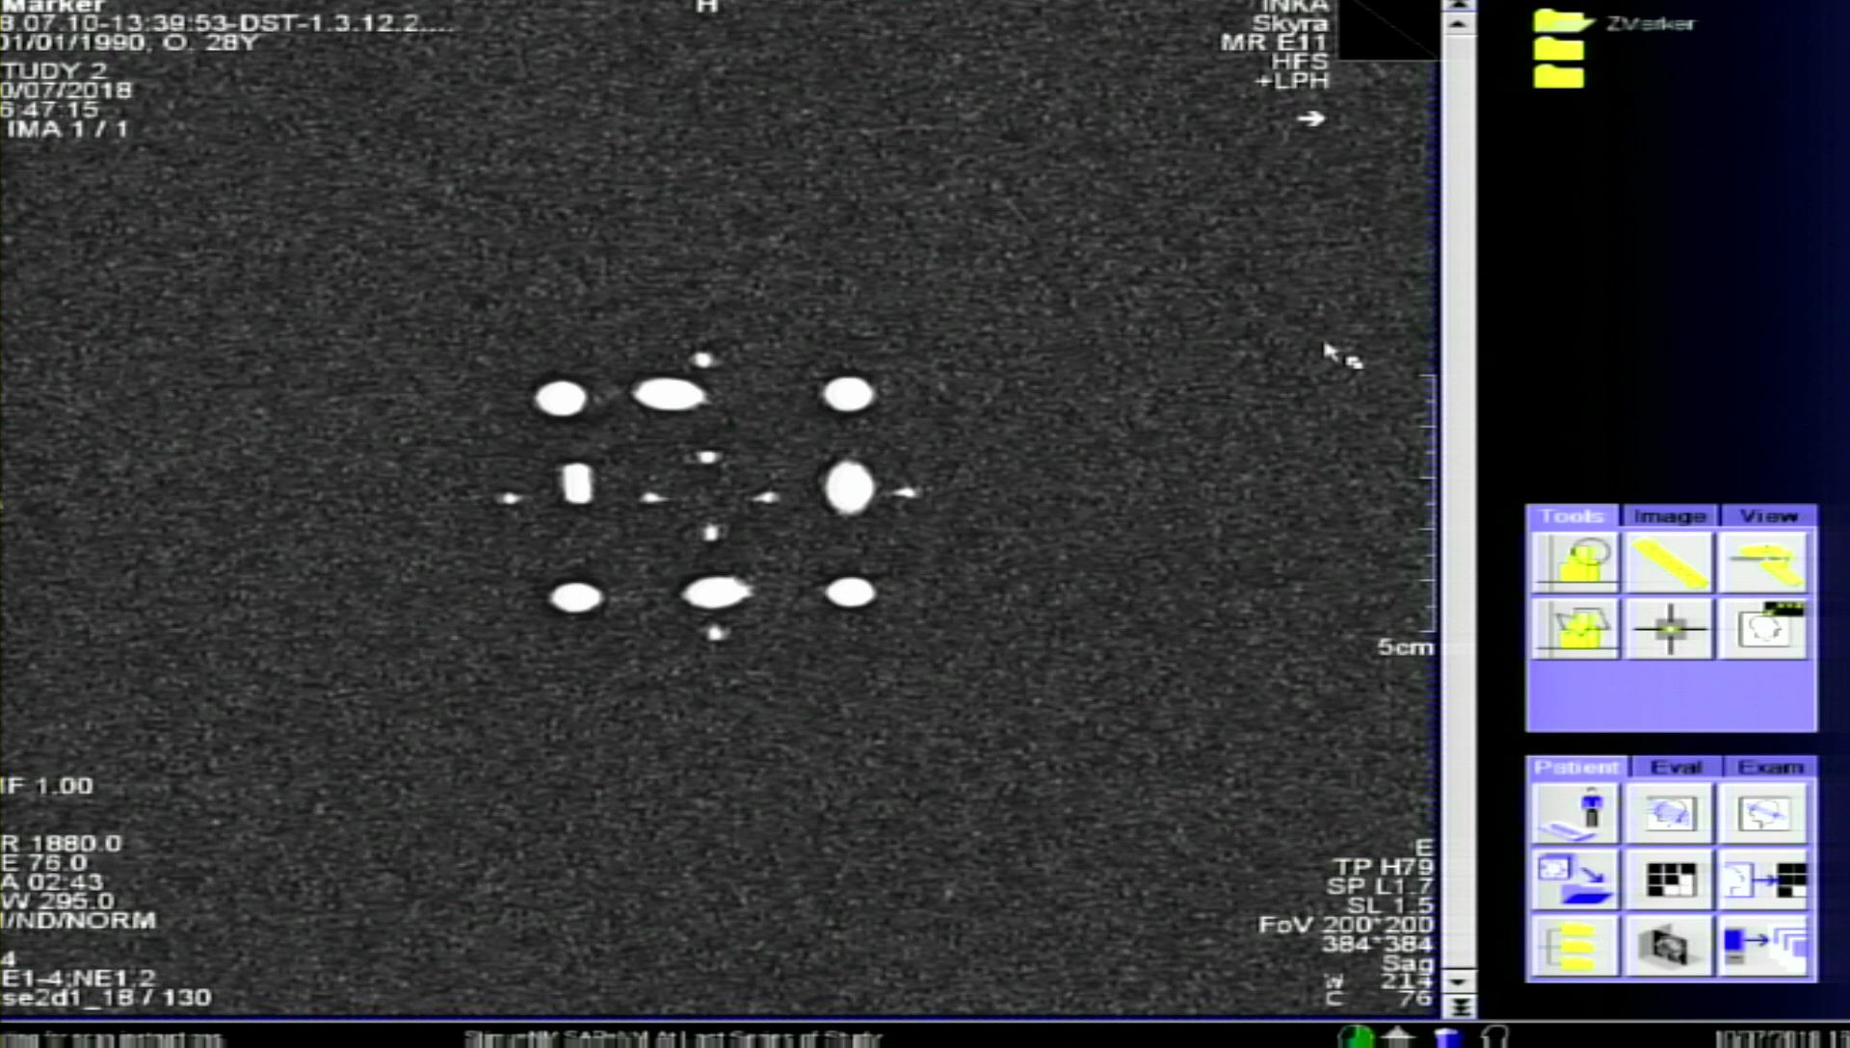

**Figure 4.5:** a snapshot of the MRI screen from T1W image of the Z-marker using the setup shown in Figure 4.2.

* 1. **Image Segmentation and Pre-Processing**

After an image from a single 2D image of the Z-marker has been obtained, the Z-marker structures should be detected from the captured-image of the MRI screen. Section 4.2.1 discusses a manual and an automatic segmentation method to separate the Z-marker from the other objects in the image. Subsequently, several filtering steps are applied to the cropped image to segment each individual ellipse of the Z-marker from the background. These steps are developed and investigated in section 4.2.2. The flow chart of the detection and localization algorithm is shown in Figure 4.2.

* + 1. **Automatic detection of Z-frame using Faster R-CNN**

Detection of the Z-marker in different position, orientation and scaling from the MRI images is a very important step to determine the marker alignment. One way to separate the Z-marker from the full-screen image is using the mouse to perform the crop operation interactively by defining a movable and resizable bounding box over the region of interest Figure 4.6.



Crop Image tool context menu

Crop rectangle

**Figure 4.6:** cropping operationfor extracting Z-marker manuaaly by MATLAB

However, this technique requires the user to repeat the process separately for each new image. In this study, a deep CNN framework is implemented with non MRI-system-specific design to perform the detection process automatically. This algorithm is able to detect the marker from the images with different imaging properties and different MRI user interfaces.

Commonly, there are three main frameworks in object detection based on deep CNNs. Regions with CNN features (RCNN), Fast Region-based Convolutional Network (Fast RCNN), and Faster Region-based Convolutional Network (Faster RCNN). However, in the image from the MRI monitor, there are many small and big objects, therefore, the use of the Faster RCNN yields a higher accuracy for the object detection task.

**4.2.1.1 convolutional neural network**

CNN is made of several layers, a convolution layer, a feature pooling layer, and a fully connected (FC) layer. Figure 4.7 shows the flowchart of a CNN.



Pool2

Pool1

CONV1

CONV2

**Figure 4.7:** Flowchart of convolutional neural network.

At the *convolution layer*, an activation function determines the output of the neural network when the feature maps from previous layers are convolved with learnable kernels and are added with a trainable bias parameter. This process can be expressed as:

$X_{j}^{l}=f(\sum_{i∈Mj}{X_{i}^{l-1} *k_{i\dot{j}}^{l}}+b_{j}^{l})$ (4.1)

In which, $X_{i}^{l-1}$ and $k_{i\dot{j}}^{l}$ are feature map and kernel respectively, $b_{j}^{}$ represents bias parameter, $f$ (.) is the activation function and $Mj$ shows a selection of the input maps.

The activation function in convolution layers has a significant effect on the training performance. Sigmoid, hyperbolic tangent, and rectified linear unit (ReLU) are three widely-used activation functions in CNN. In this work, ReLU is applied as the activation functions due to its better performance than the other two functions. As it is shown in Figure 4.8, ReLU is a half-rectified function, where f(z) is equal to zero in negative z values, and f(z) is equal to z for positive or zero values of z.

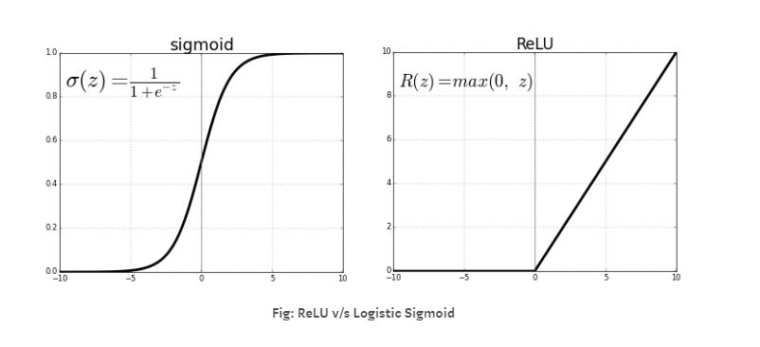

**Figure 4.8:** Logistic Sigmoid versus ReLU function.

The next layer in CNN is *Feature pooling layer* thataggregate the results of the convolutional layers and passes only the relevant and strong signals to the next layers. As it is shown in Figure 4.7, this layer selects the inputs from the small patches in the image where pooling window can have different sizes. In this project, maxPoolingLayer operation is evaluated for accomplishment of the pooling task. Equation 4.2 represents the max pooling function where u(x,y) is a window function that can be applied to each input patch for computing a feature map.

$a_{j }= \max_{N×N}\left(a_{i}^{n×n}u\left(n,n\right)\right)$ (4.2)

Source: Evaluation of Pooling Operations in Convolutional Architectures for Object

The last layer in CNN is the *fully connected (FC) layer* that has a high-level neural network structure. Neurons in this layer are connected to the activations in the previous layer, while activations in this layer are computed via the matrix multiplication with a bias offset.

Source(https://jaai.de/convolutional-neural-networks-cnn-aufbau-funktion-und-anwendungsgebiete-1691/)

Training of the all CNN layers is performed using the backpropagation algorithm to minimize the difference between the desired output and the actual output of the CNNs. Basically, RCNN is considered an outstanding method in object detection. This technique uses CNNs and a support vector machine (SVM) as well as bounding boxes for object detection task. However, each training image should be cropped to a defined size based on the FC layers and repeatedly undergo CNN process which is time-consuming. Consequently, the Fast RCNN was introduced to address these issues. In this approach, a single stage training is performed via multi-task loss process that improve the accuracy and speed of the training. Moreover, with the use of Fast RCNN, the feature caching does not require disk storage as SVM approach. Alternatively, the Softmax layer is inserted directly into the network as a replacement for SVM. This technique exhibits significant improvements in finding reasonable parameters. However, Fast RCNN still have several disadvantages, as it is not enough powerful for real-time applications. Consequently, to improve the performance and speed in Fast RCNN, Faster RCNN approach was proposed. This model proposes regions using a deep fully convolutional network called Region Proposal Network (RPN). Figure 4.9 represents the Faster RCNN configuration.

In comparison with the mentioned frameworks, Faster RCNN (FRCNN) offers certain advantages, and scientists try to develop and improve this approach. Therefore, in this project, Faster RCNN is selected as the framework.

Classification

CONV6

Bbox Regressor



g

CONV5

CONV3

CONV1

Conv Feature maps

Layers from Backboned Model

Input image

Classification

ROI Pooling

Bbox Regressor

FC6

FC7

**Figure 4.9:** Flowchart of Faster region CNN approach

**4.2.1.2 Precision and recall analysis**

Generally, there are two criteria in deep learning to evaluate the performance of the detector: average precision (AP) and recall. These parameters are defined as follows:

$average-precision=\frac{True positive}{True positive+True negative}$ (4.3)

$recall=\frac{True positive}{True positive+False negative}$ (4.4)

Where, “False negative’’ is a test result which wrongly indicates that a condition does not hold. “True negative’’ is a test result which correctly identifies that a condition does not hold. “True positive’’ is a result indicating that a given condition exists and it does exist.

In this work, the precision and recall rate of the detector is estimated using all the images in the test set to evaluate the accuracy of the detector. The Average precision result of a detector trained with 53 images is shown in Figure 4.10. The Figure 4.11 represents the automatic detection of the Z-marker with the detector.



**Figure 4.10:** Precision and recall rate plot of the detector. The whole input data is 88 images, with 60 percent for training and 40 percent for testing.

Source: A light and faster regional convolutional neural network for object detection

in optical remote sensing images

**Figure 4.11:** The detected Z-marker in the whole captured image of the MRI screen. In the left image, Z-marker structure is detected correctly, but in the right image the bounding box does not positioned correctly and some other objects from the background detected as the Z-marker.

The average precision of the convolutional network can be improved by adding more images to the data set and increasing the numbers of the convolution layer. However, it is computationally expensive and time-consuming.

**4.2.2 Noise removal of MRI images**

In magnetic resonance (MR) images, noise is commonly represented by means of a Rician distribution, since it is assumed that a zero-mean uncorrelated Gaussian noise exists in both the real and imaginary parts of the k-space MR data. However, this noise affects the results of the processing techniques applied in the MR data, such as registration, segmentation, and localization. Moreover, a tradeoff between noise reduction and the preservation of the relevant image features should be considered. Consequently, several different and robust noise removal methods have been implemented in this project that are applicable to various circumstances.

**4.2.2.1 Image denoising using Gaussian Smoothing Filter**

The Gaussian filter is a type of image-smoothing filter that commonly reduces noise by blurring the image. The Gaussian function that is defined in equation 4.5, calculates a transformation for filtering the image based on the standard deviation σ, and the distances x and y of the points from the origin in the horizontal and vertical axes. The equation of a two dimensional Gaussian function is the product of two one dimensional Gaussian functions as:

$G\left(x,y\right)=\frac{1}{2πσ^{2}}e^{-\frac{x^{2}+y^{2}}{2πσ^{2}}}$ (4.5)

Figure 4.10 represents the 2D Gaussian distribution with $σ$ = 1.

**Figure 4.10:** the 2D Gaussian distribution with $σ$ = 1 and mean(0,0).

The Gaussian smoothing filter is applied to the captured MRI images to suppress the Gaussian distributed noise. Figure 4.11 shows the image before and after filtering operation.



**Figure 4.11:** The left image shows the T1W image of the Z-marker structures acquired with capture device and AV converter. The right image shows the denoised image by blurring the image using Gaussian smoothing operation.

**4.2.2.2 Image denoising using wavelets**

The nature characteristics of wavelet transforms for preserving the edge features in images make this filter as one of the most applicable denoising technique. By applying the Discrete Wavelets transform (DWT) to an image, the image is decomposed into a series of coefficients, such as: Scaling coefficients (approximation sub-band) and wavelet coefficients (detail sub-band). The DWT tends to dominate small coefficients with low SNR by noise, while coefficients with a large absolute value and high SNR represent more signal information. Therefore, the DWT noise reduction algorithm removes low SNR coefficients and keep the prominent ones, where the Inverse Discrete Wavelet Transform (IDWT) provides the denoised image. The core task of the whole wavelet denoising is to select a suitable threshold for wavelet coefficients that preserves the features of interest in the image and suppress more noise.

One practical technique to find the most suitable threshold for denoising MRI images has been proposed by Donoho [20]. The global threshold in this method that is asymptotically optimal is defined in equation 4.6, where N is the size and σ is the standard deviation of the wavelet coefficients.

$λ=σ\sqrt{2\log{N}}$ (4.6)

Afterwards, Hard or Soft thresholding technique is used to apply the computed optimal threshold from the equation 4.6 to the wavelet coefficients. The mathematical definition of both methods are shown in equation 4.7 and 4.8 where c is the coefficient array.

$\overline{c_{h}}\left(k\right)=\left\{\begin{aligned}sign\left(c\left(k\right)\right)\left(\left|c\left(k\right)\right|\right) if \left|c\left(k\right)\right|>λ \\ 0 if \left|c\left(k\right)\right|≤λ\end{aligned}\right.$ (4.7)

$\overline{c_{s}}\left(k\right)=\left\{\begin{aligned}sign\left(c\left(k\right)\right)\left(\left|c\left(k\right)\right|-λ\right) if \left|c\left(k\right)\right|>λ \\ 0 if \left|c\left(k\right)\right|≤λ\end{aligned}\right.$ (4.8)

Figure 4.12 represents the behaviors of the thresholding functions defined in equations 4.7 and 4.8 on a linear signal.

a) original signal

b) Hard thresholded signal

c) Soft thresholded signal

signal signal

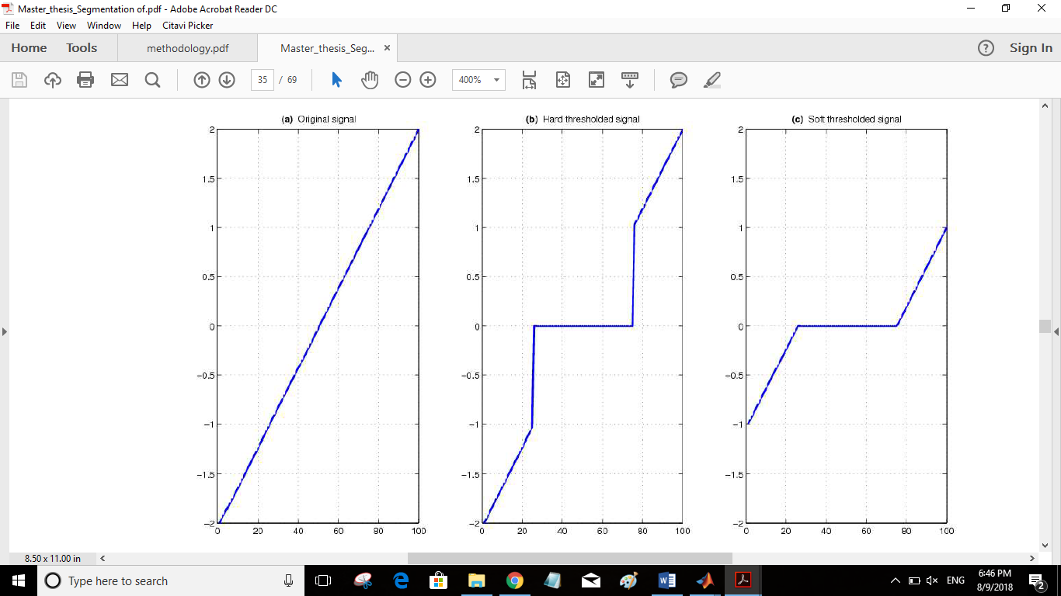

**Figure 4.12:** Theresholding of a linear signal defined in the range [0,2] with λ=1 by (b) Hard thresholding and c) Soft thresholding.

The result of the proposed denoising method for the captured MRI image is represented in Figure 4.13.



**Figure 4.13:** the left image represents the original image, and the right image shows the filtered image using wavelet with soft theresholdig method.

**4.2.2.3 Image denoising using Nonlinear Anisotropic Filtering**

The main drawback of the linear filtering mentioned in sections 4.2.2.1 and 4.2.2.2 is that the details in the original image will be destroyed during reducing the noise. Anisotropic diffusion filtering proposed by Perona and Malic [reference] is a method which reduces the image noise while preserves important details such as edges in the image. This filter is defined as an anisotropic process which uses an adapted diffusion tensor for smoothing the images. Importantly, the diffusive procedure is an inhomogeneous process which limits the smoothing in areas of interest which have a larger likelihood to be edges or boundaries.

The Perona-Malik filter performance is based on the mathematical formulation given in equation 4.9, where the rate of diffusion can be controlled with the diffusion coefficient c(x,y,t).

$\frac{∂}{∂t}I \left(x,y,t\right)=div(c\left(x,y,t\right)∇I\left(x,y,t\right))$ (4.9)

I(x,y,t) represents the image intensity and div and $∇$ denote the divergence and the gradient operators respectively. Moreover, x and y represent the spatial coordinates in the two-dimensional image, and t corresponds to the iteration number.

An important step in this technique is to select an appropriate diffusion coefficient based on the image gradient. Ideally, the coefficient should be 0 at the features of interest (edges and boundaries), and 1 at the interior of a region. Accordingly, Perona and Malik [] introduced the two mathematical equations 4.10 and 4.11 for estimating the diffusion coefficient, where the first equation has a better performance on the high contrast edges, and the second one is more suitable for the wide areas rather than the narrow ones.

$c_{1}\left(x,y,t\right)=exp⁡({⁡-(\frac{\left|∇I\left(x,y,t\right)\right|}{k})}^{2}$ (4.10)

$c_{2}\left(x,y,t\right)=\frac{1}{1+({⁡(\frac{\left|∇I\left(x,y,t\right)\right|}{k})}^{2}}$ (4.11)

In the equations 4.10 and 4.11, k is conductance parameter, and usually can be selected empirically. Moreover, it determines the difference between an edge and an intensity value destroyed by noise during anisotropic diffusion filtering process.

In addition, the diffusive procedure which applies the eq.4.9 defines the intensity change in each iteration based on the summation of contributed pixels at the neighborhoods of (x,y) which are weighted according to equation 4.12, as presented in equation 4.13.

$$Φ_{E}\left(x,y,t\right)=c\left(x+\frac{dx}{2},y,t\right)[I\left(x+dx,y,t\right)-I\left(x,y,t\right)]$$

$$Φ_{W}\left(x,y,t\right)=c\left(x-\frac{dx}{2},y,t\right)[I\left(x,y,t\right)-I\left(x-dx,y,t\right)]$$

$$Φ_{N}\left(x,y,t\right)=c\left(x,y+\frac{dy}{2},t\right)[I\left(x,y+dy,t\right)-I\left(x,y,t\right)]$$

$Φ_{N}\left(x,y,t\right)=c\left(x,y-\frac{dy}{2},t\right)[I\left(x,y,t\right)-I\left(x,y-dy,t\right)]$ (4.12)

$I\left(x,y,t+dt\right)=I\left(x,y,t\right)+dt\left[\frac{1}{{dx}^{2}}\left[Φ_{E}\left(x,y,t\right)-Φ_{W}\left(x,y,t\right)\right]+\frac{1}{{dy}^{2}}\left[Φ_{N}\left(x,y,t\right)-Φ_{S}\left(x,y,t\right)\right]\right]$ (4.13)

In the equations 4.12 and 4.13, the pixel spacing in the image is represented by dx and dy Moreover, in equation 4.13, dt corresponds to the integration constant and it has to be selected with respect to a stability criterion. Figure 4.14 shows an image which is denoised using anisotropic filter after binarization.



**Figure 4.14:** The left image is the original image and the right image is the denoised image using anisotropic filter after binarization. Equation 4.11 is used to for estimation of the diffusing coefficient.

In conclusion, based on the results presented in Figure 4.14, the anisotropic diffusion filtering approach has the best performance on the images as a preprocessing step (noise reduction and edge enhancement). Moreover, due to the mentioned characteristics of the anisotropic diffusion, the image converges faster to the desired shape for further processing.

**3.1.3 Image Contrast Enhancement**

In order to adjust the intensity value in the image, the *imadjust* function in MATLAB is implemented, while the range of the input values and the output values are specified in two vectors that pass to the *imadjust* function as arguments. The first vector specifies the low- and high-intensity values that must be mapped and the second vector specifies the scale over which the values of the first vector should be mapped to. The result of this process is represented in Figure 4.15.



**3.1.4 Image Binarization**

Thresholding is a common image processing technique applied to gray-scale images for image binarization. In general, it makes a binary partition of the image data set by using intensity values of the image pixels. Single-threshold algorithm separates the dataset into two classes based on a threshold, where, pixels with higher intensities than the threshold are categorized into one class and the other pixels are categorized in an another class. The mathematical equation of this technique is presented in eq. 3.1, where I and $λ$ correspond to the analysed intensity value the threshold respectively. This method is also called segmentation.



The difficulty in this approach is that the threshold value should be determined in a way that best differentiate the regions of interest. Practically, the result of the filter depends on the threshold value, MRI noise and inhomogeneities.

In this project, in order to distinguish between the cylindrical fiducials and the background, the user has to select a threshold based on visual inspection of the image. Therefore, any pixel for which is bigger than a threshold labeled 1 and corresponds to the fiducial maker; otherwise, the pixel corresponds to the background and labeled 0.



**3.1.5 Binary Image Mask**

At this stage, each segment which is detected as a fiducial marker, is examined based on its volume and dimensions. If the volume in a given segment is lower than a pre-defined range, it does not belong to the Z-frame structures, and should be removed from the image. Therefore, function *bwareaopen* in MATLAB is used to create a binary mask and remove small segments from the image.



* 1. **Localization and Registration**

This section is dedicated to the implemented methods for localization and registration of the Z-frame marker in the MRI image space.

* + 1. **Center Detection of the Fiducial Ellipses**

Once all 7 ellipses with the size close to the physical size of the marker were detected, the function *regionprops* in MATLAB is used to calculate the center of each fiducial marker. The result is a 7×2 matrix where the first column represents x coordinate and the second column corresponds to y coordinate of the center of the fiducial mass region. The resulting 7 centroids of the ellipses were sorted along the U-shape of the marker as illustrated in Fig.2

Depending on the attachment of the Z-frame on the robotic device, the frame has different position, scale, and orientation in the MR images, hence, the points are not always detected in the same way. Accordingly, a robust technique is required to rotate the Z-marker around its axis on the image automatically.



* 1. **Image Rotation Estimation using Automated Feature Matching**

Feature matching method, automatically determines a geometric transformation between two images that are different by a rotation or a scale change. Importantly, the features in both images should be detected with an optimal feature detection technique which is robust to rotation, scale, illumination, and noise of the images. Scale Invariant Feature Transform (SIFT) is a feature detector proposed by Lowe. SIFT is an efficient detector in object recognition applications that is invariant of the rotation, intensity and viewpoint changes in image. However, the main drawback of SIFT is the long time for feature computation procedure. Alternatively, Speed up Robust Feature (SURF) technique, with the same principle of SIFT, has a higher computational speed without reducing the quality of the detected features. It has to be mentioned that both SIFT and SURF methods are based on a detector and a descriptor. In this project, both SIFT and SURF are implemented. Once, the image features and descriptors are detected, the corresponding features in each image will be matched. The point matched are shown in Fig. Therefore, a transformation matrix based on the matching point pairs is computing using the statistically robust M-estimator SAmple Consensus (MSAC) algorithm. Matching point pairs used in the estimation of the transformation matrix is displayed in Fig.2. The desired angle of rotation is calculated using the geometric transform from the last step. The recovered and the reference image is shown in Fig. This technique requires the detected features be highly distinctive to be correctly matched with high probability. However, the fiducial markers have a different shape in different imaging slices. In addition, artefacts and noises in MRI have an effect in the roundness of ellipses which make the algorithm unable to find the match features in the images as it is figured in Fig..



* + 1. **Image Rotation using centroids coordinate system:**

In this technique, the seven centroids position of fiducial markers is used to compute a rotation matrix that rotates the points in the image coordinate system. Since the four outer points of the Z-marker has a constant distance to each other, the points with maxim Euclidean distances with its three neighbors are detected as the outer points. Once all four outer points are detected, the correct position of them should be determined in z marker. The point with minimum x coordinate is detected as p1 and one with maximum x is determines as p7, however, their y coordinates should be compared for an accurate estimation. Totally, four different rotation models of the Z-marker are possible, which algorithm should select automatically the correct one and rotate the marker based on that. As it is figured in Fig.1.





Fig .15: Four different possible rotation of the Z-marker

D=270

D=180

D=0

D=90

innerpoint

innerpoint

In the next step, the algorithm detects the nearest neighbors of the p1, if it has only one neighbor, the z marker has one of the fig a or b, and if it has two neighbors fig c and d are possible. Then, algorithm searches for a point called *innerpoint,* which is located between p1 or p7 and the point with a minimum y coordinate as it is shown in Fig.1. Hence, one type of the rotation is determined by the algorithm. The rotation angle 𝜃 is defined in equation1.

𝜃=β+D

β= 𝛼-45

Where 𝛼 is the angle between the line that is made by p1 and p7, and the line which passes through p1 and is parallel to the y axis as it is presented in Fig1. D corresponds to the defined angle that is different in each model for making the z marker as a U shape structure. Therefore, a rotation matrix is calculated to be multiplied with the centroids matrix. The ordered set of fiducial point coordinates *P’* are then applied to compute the 6-DOF pose of the Z-frame with respect to the image plane. Finally, the computed frame position and orientation is used to compute the required motion of the robotic device to reach the target pose.

* + 1. **Distance calculation and calibration**

In the calibration part, a coefficient should be calculated to transfer points from image coordinate system to the frame coordinate system. In DICOM images, pixel spacing is defined as the physical distance between the centers of each two-dimensional pixel. However, in screen shot images, the resolution of the MRI monitor and the capture device influence the distance. To overcome this problems, a coefficient is calculated based on equation 1. Where, *µx* is the row spacing or vertical spacing in mm, *µy* is the column spacing or horizontal spacing in mm, Pi is the center points of the fiducial markers and d is the Euclidean distance between points. d’ is the distance between points in physical space in mm.

µx = (|d’/d (P5, P3) |+abs|40/d (P1, P7) |)/2

µy = (|d’/d (P3, P1) |+abs|40/d (P5, P7) |)/2

Figure represents the pixel spacing in vertical and horizontal direction.

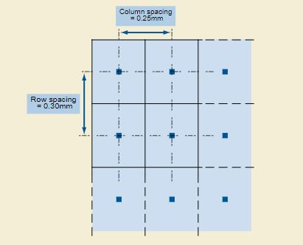

Figure 7 Example of Pixel Spacing Value Order

Source: https://dicom.innolitics.com/ciods/ct-image/image-plane/00280030

In the next step, the coordinate of the centers is transferred to the center of the z-marker.



* + 1. **Marker Alignment Calculations**

Once the center of all 7 fiducials was calculated and calibrated, the position of the three corresponding points in frame coordinate system was estimated according to Eq.1. A transformation matrix is required to map these points to the corresponding points in the MR scanner’s coordinate system. However, an exact rigid transformation between points in frame coordinate system and the corresponding points in the MR scanner’s coordinate system would not exist due to geometric distortion in MRI images. Thus, a rigid transformation that minimizes the sum of squared distances between corresponding points was calculated using Procrustes function in MATLAB. As a result, any point in the frame coordinate system can be mapped in MR coordinate system using Equation.

$$P_{mr}=R_{f}P_{f}+T_{f}$$

Where Pmr and pf are the points in MR coordinate system and frame’s coordinate system respectively. RF is a rotation matrix and Tf is a translation vector.

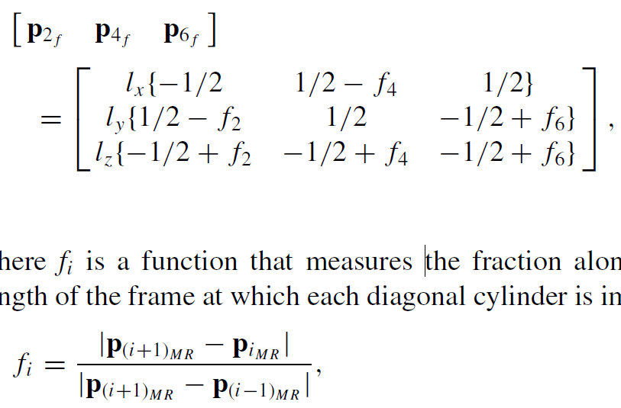



* + 1. **Angle Calculation of the MR Image Plane and Z-frame Marker**

In this stage, the angle between MR image plane and the Z_marker was calculated to confirm the parallelization of the marker. When the MRI plane and the marker plane intersect, an angle between them is formed that can be calculated by the use of normal vectors of the given planes. The equations of two intersecting planes are given by:

∏1: a1x+b1y+c1z+d1=0

∏2: a2x+b2y+c2z+d2=0

Normal vector which is a perpendicular vector to a plane is (a,b,c).

${\vec{n}}_{1}$ = normal vector to plane ∏1 = (a1, b1, c1)

= normal vector to plane ∏2 = (a2, b2, c2)

Then the angle between these planes (the angle between the normal vectors) is calculated by the following formula.

$$\cos{α=}\frac{\left|{\vec{n}}_{1}⋅{\vec{n}}_{2}\right|}{{\vec{n}}_{1}{\vec{n}}_{2}}$$

Then the angle between the marker plane and yz plane (for rotation around x axis) and xz plane (for rotation around y axis) were calculated based on mathematical formulation 2.

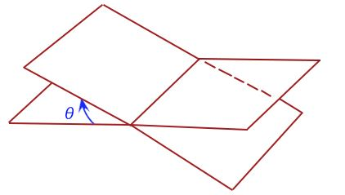

To do that the normal vector of the plane containing three corresponding points P2, P4, P6 in the frame coordinate system was computed (Fig.).



Moreover, the right rotation of the marker has to be estimated to find a correct rotation of the robotic device. The triangle feature discussed in section 3 is used to determine the z-axis direction in the image. For example, if the triangle is located in the right side of the marker, the z axis should be inverted. (fig.2)

To estimate the rotation direction around y axis the z components of the p2 and p6 is compared. If p2 has a bigger z value and the triangle is in the left side, it shows that rotation is positive, otherwise the rotation is negative. In the case that triangle is in the right side the z axis is inverted and bigger z value of p2 represent the negative rotation around y axis.

The result is discussed in the section.

**3.2.1 Registration error distribution of the z-marker**

An accurate registration of the Z-marker requires the true localization of the fiducials. However, in real world, localizing fiducials usually is not errorless and results in appearing an error known as fiducial localization error (FLE) that results in two registration errors known as fiducial registration (FRE) and target registration error (TRE). FRE is defined as the error in aligning corresponding fiducials after the registration, and TRE is defined as the error in aligning corresponding targets after the registration. TRE is an important measure in defining the accuracy of a fiducial system during the surgery. However, calculating the actual TRE at a target location during a surgery is difficult and time consuming. Instead, measuring FRE during the surgery after localization and registration of the fiducials is simple. Accordingly, FRE determines the accuracy of the fiducial localization. (the distribution… paperr)

1. **Results**
   1. **Implementation**

The automatic alignment detection algorithm which integrates the methods describes in Section 4 has been implemented using a Graphical User Interface in MATLAB R2017a. The use of GUI makes the interaction of the user with the processing steps much easier. A brief description is given here for each of the buttons and panels, for a better understanding of the offered capabilities.

* *Import image data* panel. It includes a popupmenu button for setting the path of the image volume to be analyzed. The user has three options: importing the image from a folder containing the images of the scan, or triggering a webcam or a capturing device.
* *Input parameters* panel:
* *Z-frame segmentation* panel:
* *Image pre-processing* panel: it implements the noise removal, contrast enhancement, binarization, and small object removal.
* *Center detection* panel: Using the binarized image produced in the previous step, an algorithm for computing
* *Calibration* panel: it implements the rotation of the 7 fiducial points detected in the last step and transforming the points to mm by using pixel spacing parameter. In addition, in this step the coordinate system of the points is transformed to the center point of the Z- marker.
* *Alignment detection* panel: in this step, the angles of the Z-marker and image plane is calculated as explained in section?
  1. **Test**

In this section, we have investigated the accuracy of the software algorithm for detection markers in data sets used for image-guided surgery.

For this part look at the article “automated fiducial marker detection for patient registration …”.

**4.2.1 Accuracy study**

In order to determine the registration accuracy, a testing platform which was manufactured by … with … was designed. As the ground through, relative positions and orientations were tested in the experiment. Several groups of images were taken at each position and orientation. (2012SPIE_Zframe)

At MRI scan on 10.07 we have tested the Zmarker with a gyroscope manufactured by Lego. The rotation around y axis was tested where the rotation around x axis was fixed. We have test the accuracy of the rotation angle by changing some MR parameters, such as slice thickness and bandwidth. We have started from 0 degree and then increased and decreased the angle by factor 5 (7 different angles). The angles close to 0 was calculated more accurate.

For the next test we need to improve the scaling procedure to read the angle better.

**Placement of Fiducial markers**

**Data acquisition**

**Marker detection**

**Influence of marker size**

**Influence of Threshold**

**Conclusion**

this chapter gives a short discussion on the achievements of this work, concluding and avaluating the results and giving suggestions for further work to be undertaken.

In this thesis, an application is developed to facilitate the tool registration in MR imaging. The main purpose of developing a standalone application, which interacts with the user for an accurate registration, has been accomplished

**Further work**

this work includes a comprehensive analysis of … . Further work can be undertaken to eider improving the segmentation algorithm which

.